BIT 4107 – MOBILE APPLICATION DEVELOPMENT
ENHANCED PROFESSIONAL STUDENT LOGBOOK
Student Name: LENNOX MACHARIA
Admission Number: BIT/2024/52639
School/Faculty: COMPUTING AND INFORMATICS
Programme: MOBILE APPLICATION DEVELOPMENT
Academic Year: 2025/2026
Semester: 3.2
Lecturer: MR NYORO MICHAEL
Phone Number: 0115990594
WEEK 1: INTRODUCTION TO MOBILE APPLICATION DEVELOPMENT
Practical Activities Undertaken
• Studied the concept of mobile application development.
• Learnt the importance and applications of mobile applications.
• Explored Android and iOS mobile platforms.
• Installed Flutter SDK and related development tools.
• Created a simple Flutter project.
• Examined the Flutter project structure and widget architecture.
Screenshots/Evidence Attached
Tools/Software Used
• Flutter SDK
• Visual Studio Code
• Android Studio
• Git
• Windows Operating System
Personal Reflection
During this week, I acquired foundational knowledge of mobile application development and learned the basics of Flutter. This provided a strong foundation for understanding the concepts and skills required to develop mobile applications throughout the course.
WEEK 2: MOBILE DEVELOPMENT ENVIRONMENT
Practical Activities Undertaken
• Configured Flutter environment variables.
• Installed Android Studio and Android SDK.
• Installed required SDK components.
• Created and configured Android Virtual Devices (AVDs).
• Verified installation using Flutter Doctor.
• Successfully ran Flutter applications on an emulator.
Screenshots/Evidence Attached
Yes
Tools/Software Used
• Flutter SDK
• Android Studio
• Android Emulator
• Visual Studio Code
• Git
Personal Reflection
During this week, I successfully set up the mobile application development environment and learned how to run applications on Android emulators. This experience strengthened my troubleshooting abilities and improved my understanding of software configuration for mobile development.
WEEK 3: USER INTERFACE DESIGN
Practical Activities Undertaken
- Designed user interfaces using Flutter widgets.
- Developed Login Screen.
- Developed Registration Screen.
- Developed Dashboard Screen.
- Developed Course Screen.
- Developed Assignment Screen.
- Developed Results Screen.
- Developed Event Screen.
- Implemented navigation between application screens.
- Applied layouts using Scaffold, Column, Row, and Container widgets.
- Customized themes and application appearance.

Screenshots/Evidence Attached
Yes
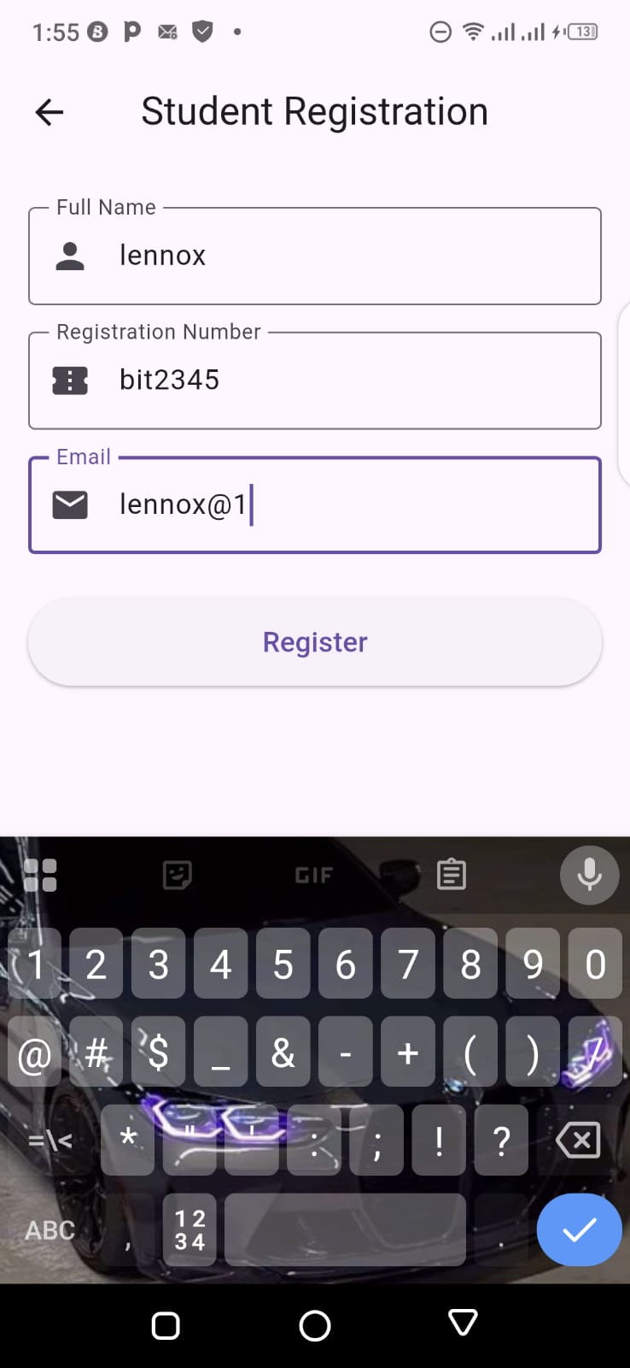
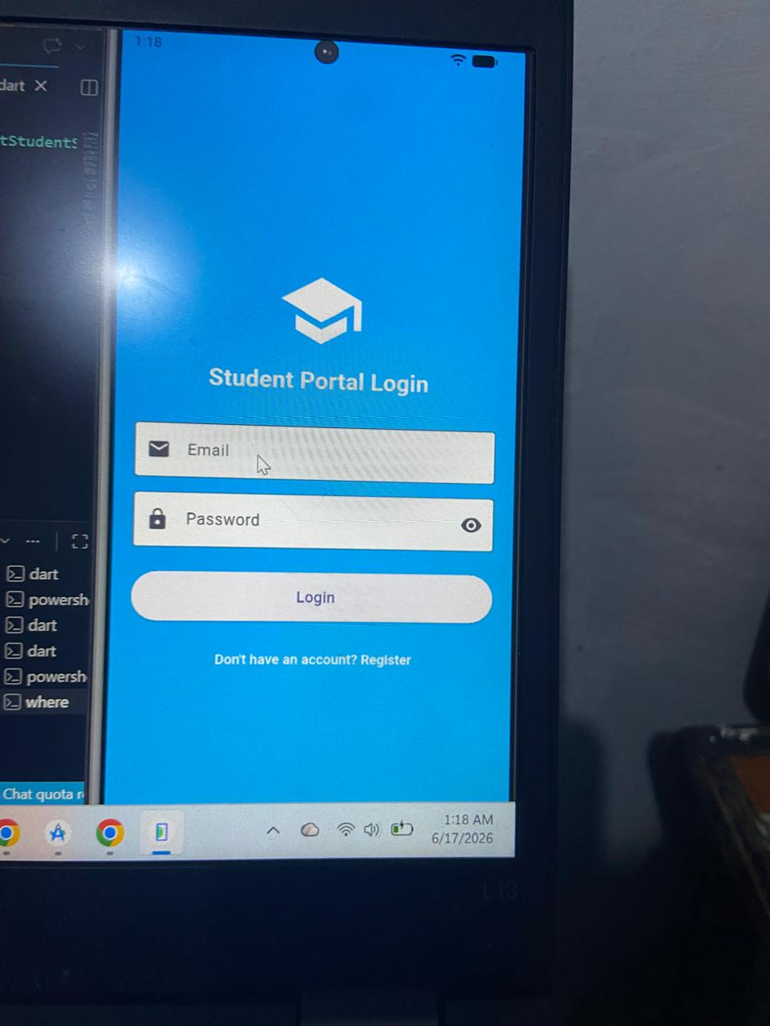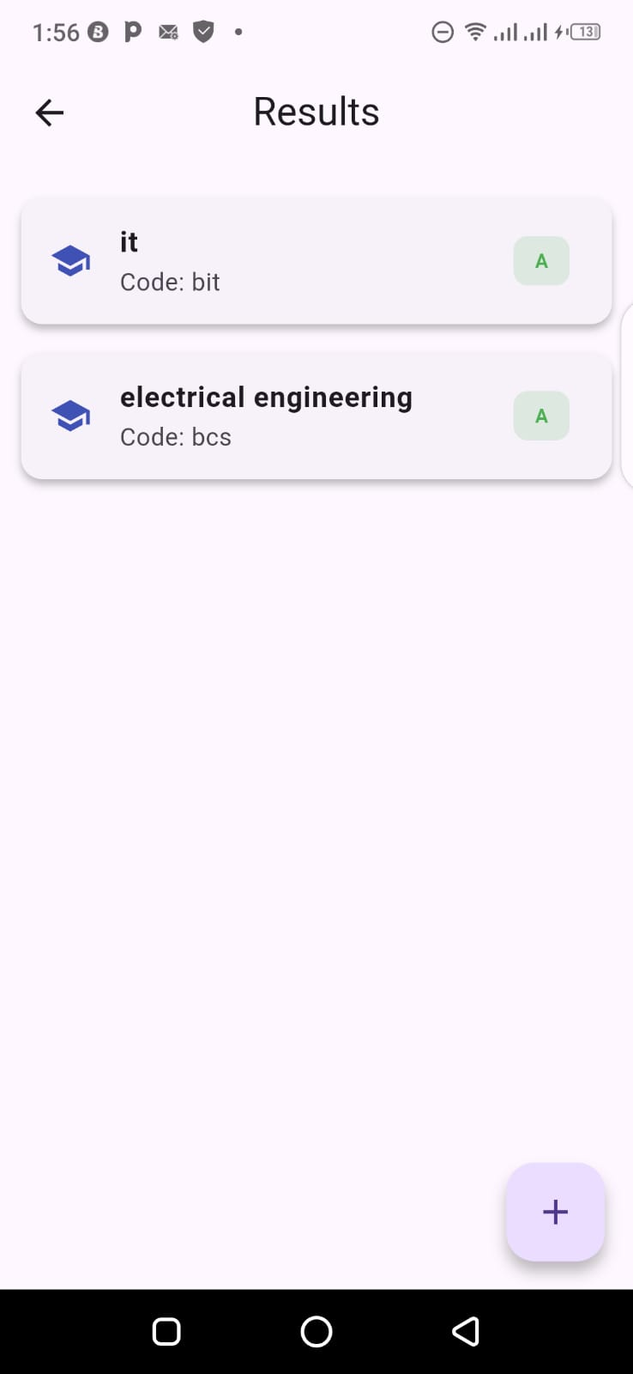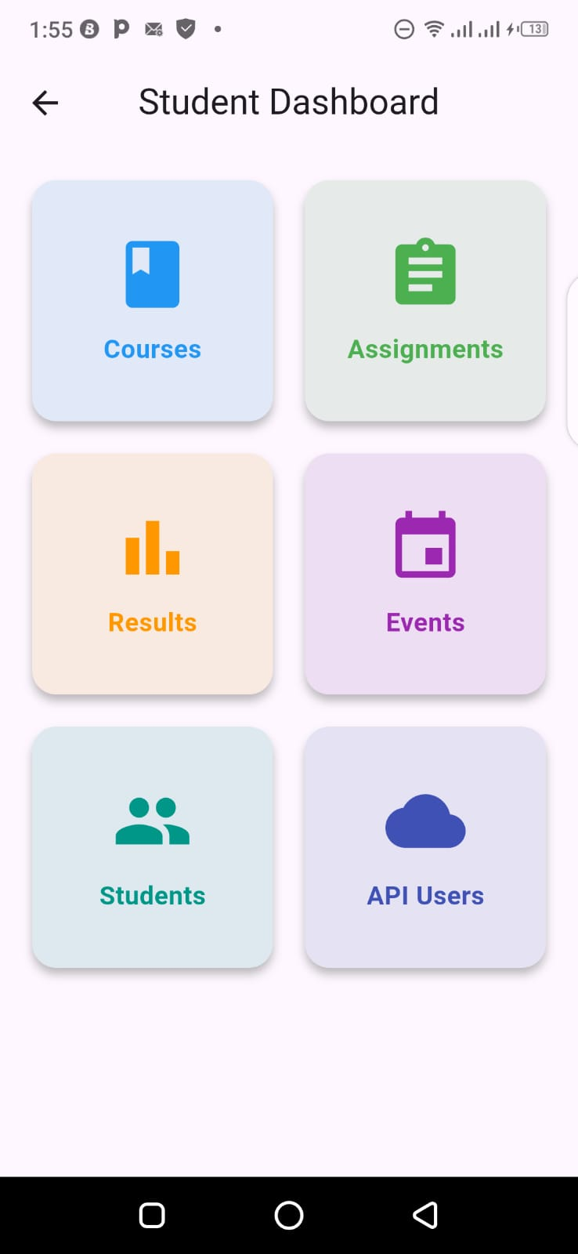
Tools/Software Used
• Flutter SDK
• Visual Studio Code
• Android Emulator
Personal Reflection
I learned how to design responsive user interfaces using Flutter widgets. These activities enhanced my understanding of application navigation and user experience design principles.

WEEK 4: EVENT HANDLING AND USER INTERACTION
Practical Activities Undertaken
• Created a new Flutter application named Mobile Application.
• Implemented user interaction using buttons and form controls.
• Developed Add Students functionality.
• Created Student List screen for displaying records.
• Implemented navigation between screens.
• Developed Edit Student functionality.
• Implemented Delete Student functionality.
• Added form validation for user input.
• Tested user interaction and application flow.
Screenshots/Evidence Attached
Yes
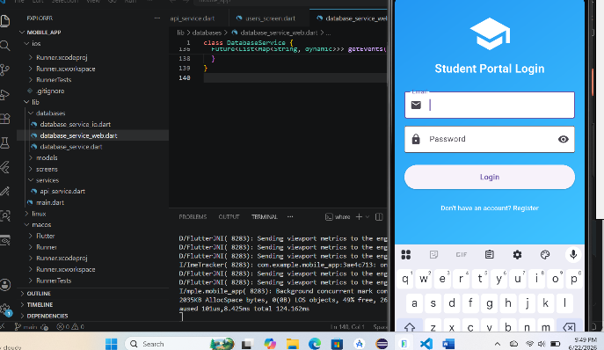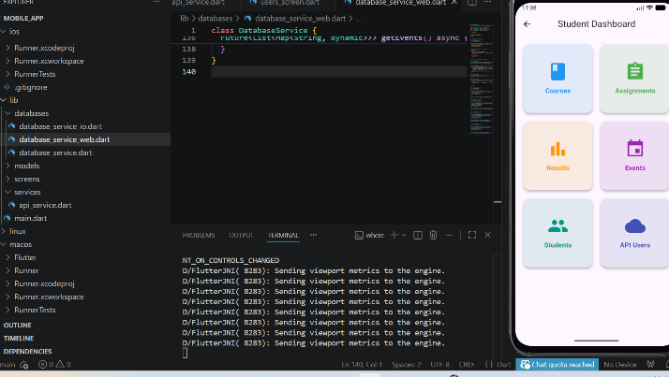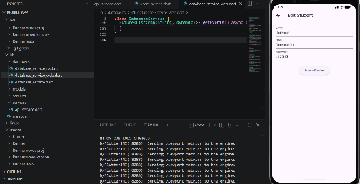.

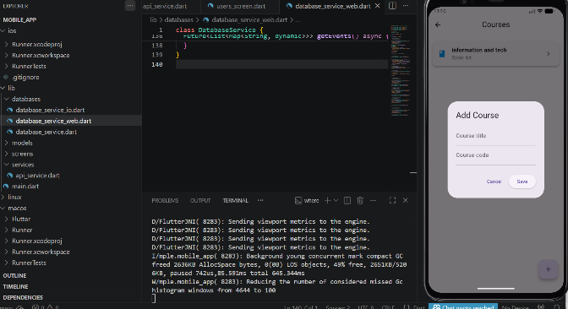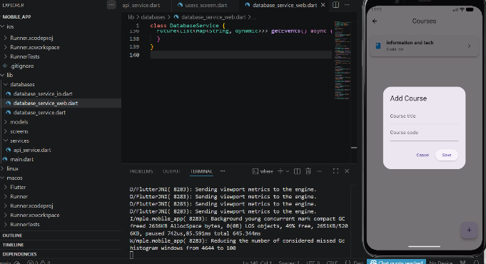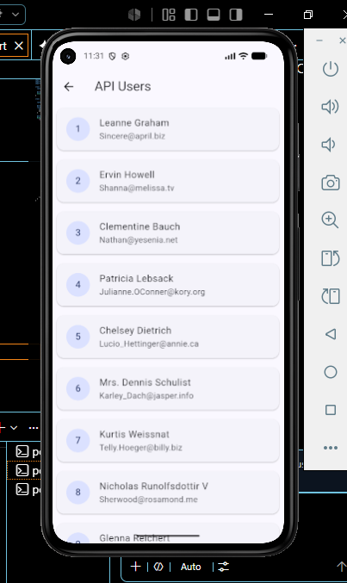
Tools/Software Used
• Flutter SDK
• Visual Studio Code
• Android Emulator
• Dart Programming Language
Personal Reflection
I learned how to handle user interactions and events within a Flutter application. Implementing navigation, validation, editing, and deletion improved my understanding of application functionality and enhanced the overall user experience design.

WEEK 5: DATA MANAGEMENT
Practical Activities Undertaken
• Implemented local data storage using SQLite.
• Created a database .
• Designed a Student model for storing information.
• Implemented CRUD operations:
- Create Student
- Read Student
- Update Student
- Delete Students
• Retrieved and displayed stored records.
• Implemented search functionality.
• Integrated API consumption concepts.
• Retrieved external data from a public API.
• Displayed API records within the application.
• Tested database and networking functionality.
Screenshots/Evidence Attached
Yes

Tools/Software Used
• Flutter SDK
• SQLite Database
• HTTP Package
• Visual Studio Code
• Android Emulator
• Dart Programming Language

Personal Reflection
I gained practical experience in managing application data using SQLite and integrating external APIs. The implementation of CRUD operations and API consumption enhanced my understanding of data persistence and mobile application networking.

WEEK 6: Networking aspects in mobile application development

Task 1: Mobile Application Network Analysis
The table below identifies the networking components used by selected mobile applications.
Application | Client | Server | Data Exchanged
WhatsApp | Mobile application used by the user | WhatsApp servers | Text messages, voice notes, images, videos, documents, calls
Facebook | Facebook mobile app or web browser | Facebook servers | Posts, comments, messages, photos, videos, user profiles
Uber | Uber Rider and Driver applications | Uber servers | Ride requests, GPS location, driver information, payment details
M-Pesa | M-Pesa mobile application or USSD | Safaricom M-Pesa servers | Account details, transaction information, payment requests, balances
YouTube | YouTube mobile application or web browser | Google/YouTube servers | Videos, comments, search queries, user subscriptions

Explanation
- Client: The user's mobile application or web browser that sends requests.
- Server: The central computer that stores data, processes requests, and sends responses.
- Data Exchanged: The information transmitted between the client and the server through the internet.

Task 2: API Investigation

API Name
JSON Placeholder REST API

Purpose
JSON Placeholder is a free online REST API used for learning, testing, and developing applications without requiring a real backend server.

GET Request Example
GET https://jsonplaceholder.typicode.com/users

Expected Response
The API returns a JSON array containing user information.
Example:
[
{
"id": 1,
"name": "Leanne Graham",
"username": "Bret",
"email": "Sincere@april.biz"
}
]

Response Description
Field | Description
id | User identification number
name | User's full name
username | Username
email | User's email address

Task 3: JSON Creation
The following JSON represents student information.
{
"students": [
{
"registration_number": "SCT221-0010/2024",
"name": "John Kamau",
"course": "Computer Science",
"year_of_study": 2
},
{
"registration_number": "SCT221-0025/2024",
"name": "Mary Wanjiku",
"course": "Information Technology",
"year_of_study": 1
},
{
"registration_number": "SCT221-0038/2024",
"name": "Brian Otieno",
"course": "Software Engineering",
"year_of_study": 3
}
]
}

Conclusion
This exercise demonstrated the networking architecture used by modern mobile applications, introduced the concept of consuming data from public REST APIs, and illustrated how JSON is used to structure and exchange information between applications and servers. These concepts form the foundation of modern mobile application development using Flutter.

